Do Ho Suh Cause and Effect Piece

Name
Institution affiliation
Course
Tutor
Date

Over the years, Do Ho Suh has caught people’s attention with misplaced houses, symbolic installations of floors and even a robe made of dog tags; yet it is his utilization of the human form that is most provocative. The artist’s work continually questions the identity and individuality of a person through the use of the human body (World Corporation, 2017). In order to clearly elaborate the issues of identity, interpersonal space, and even the transitory existence qualities, Suh developed the Cause and Effect piece, which will be adequately explored in this essay.
According to Suh, Cause, and Effect is a ceiling installation that incorporates miniature men statues, even though they are mounted on top of each other, evoking a spiteful tornado of minute bodies. These men are heaved upon each other’s shoulders as if they were deliberately cooperating so as to build a larger force (Kazuyo and Ryue, 2011). Here, Suh continues to stress his observational message of there being strength in numbers. Originally, Suh meant to create the Cause and Effect piece so as to portray the distinction amid the larger group and the individual being. Thus, as per this piece, the audience is forced to think with the pure scale of the piece about his/her identity.
Regardless of their minimal form, these 5.5-inch-tall representative men attest to be a powerful unit after merging their combined efforts. The acrylic gum figures are seeing to cling on towlines that are attached to a stainless steel plate, stretching out eight feet across and reaching an estimated elevation of nineteen feet (Robertson & McDaniel, 2013). Furthermore, Do Ho Suh’s use of red, orange and yellow colors to paint the miniature statues was intended to resemble a Doppler reading so as to further stress the look of a vicious tornado representing the expansive strength of a group of people.

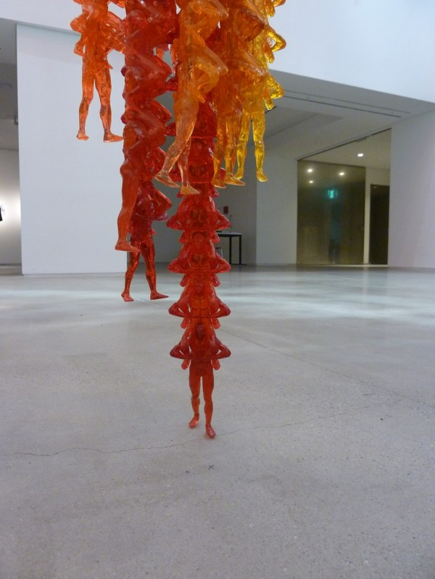Do Ho Suh's "Cause & Effect: A Vortex of Little Orange Men." Courtesy the artist and Lehmann Maupin Gallery, New York

References
“Do Ho Suh.” Do Ho Suh Biography – Do Ho Suh on Artnet, Artnet, Worldwide Corporation, (2017). Retrieved fromwww.artnet.com/artists/do-ho-suh/biography
Kazuyo S. and Ryue N. (2011). 21st-century museum of contemporary art, Kanazawa, Ishikawa Prefecture, Japan. Architectural Design,81(1), 94-101.
Robertson, J., & McDaniel, C. (2013). Themes of contemporary art: Visual art after 1980. New York: Oxford University Press.

